
Faculty of Resource Science and Technology (FRST)

COURSE:
STB1083 Biochemistry
Glycolysis, Kreb Cycle and Electron Transport System
PBL (2)
Group:
Name | Matric No. | Group
Lee Jie Ying | 70148 | 4
Chow Ying Qi | 69365 | 4
Kee Bee Hoon | 70059 | 4
Chairperson: Lee Jie Ying (70148)
Scriber: Kee Bee Hoon (70059)

Lecturer: Dr. Rosmawati bt Saat
NO | FACT(S) | IDEA(S) | LEARNING ISSUES |  | ACTION PLANS(S)
1. | 23 years old man developed an irregular heart rhythm, complained lethargy, tremor of hands and arms. | He has an unhealthy lifestyle which means can cause many serious diseases. | - What is Atrial Fibrillation?  - What causes irregular heart rhythm?  - How to treat lethargy?  - What are the symptoms of tremor?  - What are the preventions for these diseases?  - What age will have the risk of irregular heart rhythm? | 1. -Common types of arrhythmia, which are irregular heart rhythms that can interrupt the normal flow of blood  -Atrial fibrillation causes your heart to beat much faster than normal. (In some cases, it can be considerably higher than 100 beats a minute)  *A normal heart rate should be regular and between 60 and 100 beats a minute when you're resting.  Symptoms:  - heart palpitations  - chest pain  - fatigue  - shortness of breath  - weakness  - lightheadedness  - dizziness  - fainting  - confusion  - intolerance to exercise  2. -Heart’s upper and lower chambers do not work together as they should because of faulty electrical signalling  -signals in the upper chambers of your heart are chaotic  -The ventricles also beat rapidly, but not as rapidly as the atria, as not all the impulses get through. (*Normally: contract at the same speed)  -When this happens, the lower chambers do not fill completely or pump enough blood to your lungs and body.  Conditions that triggered  - Medications include caffeine, amphetamines  - high blood pressure  - congestive heart failure  - heart valve disease  - hypertrophic cardiomyopathy - the heart muscle becomes thick  - heart surgery  - congenital heart defects- heart defects you’re born with  - an overactive thyroid gland  - pericarditis- inflammation of the sac-like covering of the heart  3. Lethargy- state of tiredness, weariness, fatigue, or lack of energy. It can be accompanied by depression, decreased motivation, or apathy  Treatment  - exercising  - drink plenty of water.  - eating a healthy diet  - getting plenty of sleep  - reducing stress levels  4. Tremor- an unintentional and uncontrollable rhythmic movement of one part or one limb of your body (can occur in any part of the body and at any time), usually the result of a problem in the part of your brain that controls muscular movement.  Symptoms  - shaking voice  - nodding head  - fatigue after exercise  - brain tumors  5. -cardioversion  -a procedure that can be undertaken to treat atrial fibrillation.  -It involves the giving the heart an electric shock and is intended to normalize the electrical activity of the heart.  6. -spiking after age 50 for men and age 60 for women (*increases as people age and become overweight or obese- sedentary life) | Discussion
2. | Complained about anxiety, sweating and hunger | The man experiences anxiety, sweating and hunger. | - What cause a person anxiety?  - What are the symptoms of anxiety?  - Does his regular diet affect the symptoms mentioned?  - Why does he experience such actions? | 1.Environmental factors  -Stress from a personal relationship, job, school, or financial predicament  Genetics  -People who have family members with an anxiety disorder are more likely to have one themselves  Medical factors  -side effects of medication  Skipping meals  -blood sugar may drop, lead to jittery hands and a rumbling tummy which in turns trigger anxiety  Public events or performances  -Public speaking, talking in front of your boss, performing in a competition  Health issues  -a health diagnosis that’s upsetting or difficult, such as cancer or a chronic illness  2. Symptoms  -feeling nervous, restless or tense  -sweating  -trembling  -feeling weak or tired  -breathing rapidly  3. -Probably yes  -due to not enough carbohydrate  -eating foods with less carbs than usual without reducing the amount of insulin taken  -timing of insulin based on whether your carbs are from liquid versus solids can affect the blood sugar level. Liquids are absorbed much faster than solids.  -the composition of the meals depends on how much fat, protein and fibre are present.  4. -when triggered by hypothalamus in the brain, apocrine and exocrine sweat glands secret sweat.  -The evaporation of sweat, composed mostly of water, salt and electrolytes, creates a cooling effect that helps maintain body temp.  -stress and anxiety cause the body to secrete the fight or flight hormones that prepare us for action.  -These hormones cause our breathing rate to increase, our heart to beat faster, our blood pressure to rise and our sweat glands are activated to produced more sweat. | -brain storming session  -Discussion
3. | Blood sugar level is 2.7 mmol/L | The blood sugar is low. | - What are the range for low blood sugar levels and high blood sugar levels?  - What causes the blood sugar low?  - What are the treatments for low blood sugar levels and high blood sugar levels?  - How does low blood sugar level relate to glycolysis?  - What is the process of Kreb cycle? | 1. low blood sugar levels (hypoglycaemia) lower than 50 mg/dL.  high blood sugar levels (hyperglycaemia)  higher than 200 mg/dL  *normal range of blood glucose- from 70 to 100 mg/dL  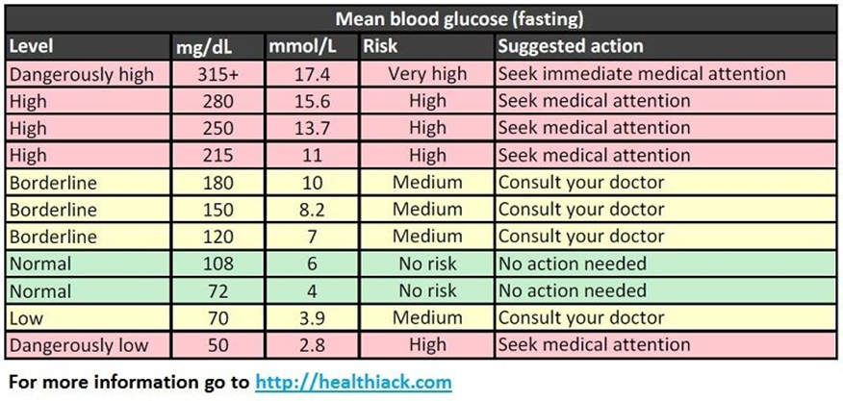  2. -Taking too much insulin or diabetes medicine  -Not eating enough during meals or snacks after you have taken insulin or diabetes medicine  -Skipping meals  -Exercising a lot or at a time that is unusual for you  -Not checking your blood sugar or not adjusting your insulin dose before exercising  -Drinking alcohol  -endocrine disorders, such as adrenal gland deficiency  3. Low  - Medication  - Exercise  - Diet- Don't skip or delay meals or snacks  - Adjust your medication or eat additional snacks if you increase your physical activity  - Record your low glucose reactions- help you and your health care team identify patterns contributing to hypoglycemia and find ways to prevent them.  High  - Eat regular meals & control portion size  - Drink sugar-free and caffeine-free liquids.  - Exercise regularly  - Reduce carbohydrate intake  - More frequent blood glucose monitoring with accurate record keeping (Monitor glucose every 4 hours)  - Take usual medications on schedule, especially long-acting insulin for an individual with type 1 diabetes. If the patient is unable to eat, contact their health care provider for medication adjustments.  - Stay hydrated. Drink at least 1 glass of water per hour.  - Monitor for symptoms of ketoacidosis, such as fruity-smelling breath, nausea and vomiting, stomach cramps, and unconsciousness.  4. -Glycolysis~ a simple pathway of glucose metabolism, critically regulates insulin secretion and metabolic functions of various cells/ control of blood glucose homeostasis  -Depending on cell types, rates of glycolysis are determined at various steps of glycolysis that are subjected to the control of key metabolic and regulatory enzymes which include glucokinase, 6-phosphofructo-1-kinase and 6-phosphofructo-2-kinase/ fructose-2-6-bisphosphatase.  -Dysregulation of glycolysis occurs in conditions of insulin deficiency or resistance and is attributable to inappropriate amount and activities of metabolic and regulatory enzyme of glycolysis.  -Targeting key metabolic and regulatory enzymes to enhance glycolysis may offer viable approaches for treatment of diabetes.  - glycolysis is important in the cell because glucose is the main source of fuel for tissues in the body. If the blood sugar level continues to drop, the brain does not get enough glucose and stops functioning as it should. Starving the brain of glucose, it may lead to seizures, coma and death.  -Human produce insulin in response to the ingestion of carbohydrates  -low blood sugar levels depress insulin production and stimulate the pancreas to release the hormone glucagon, which inhibits glycolysis.  5. -Also known as citric acid cycle/ tricarboxylic acid cycle (TCA cycle)  -Before: In order for pyruvate from glycolysis to enter the Kreb's Cycle it must first be converted into acetyl-CoA by the pyruvate dehydrogenase complex which is an oxidative process wherein NADH and CO2 are formed. Another source of acetyl-CoA is beta oxidation of fatty acids.  8 steps  1. Formation of citrate  2. Formation of Isocitrate  3. Oxidation of Isocitrate to α-Ketoglutarate.  4. Oxidation of α-Ketoglutarate to Succinyl-CoA  5. Conversion of Succinyl-CoA to Succinate  6. Oxidation of Succinate to Fumarate  7. Hydration of Fumarate to Malate  8. Oxidation of Malate to Oxaloacetate | Discussion

